1. A black screen with white text

   Description automatically generated
2. 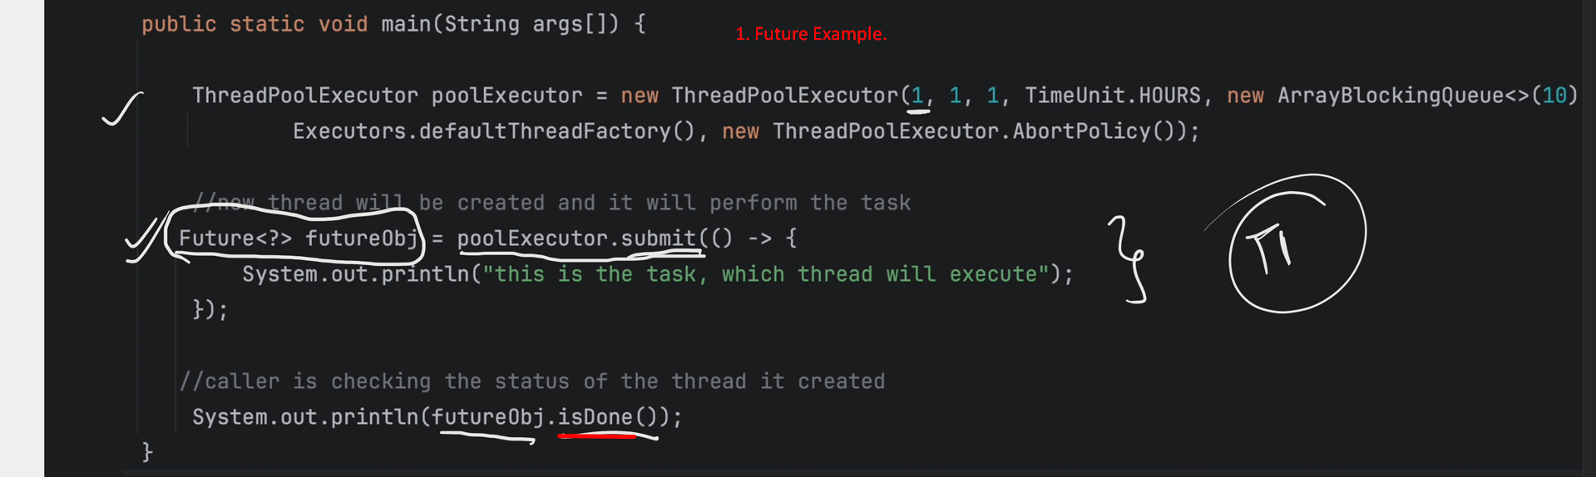
3. Future<?> API  
   A black and white screen with white text

   Description automatically generated  
    A screenshot of a computer

   Description automatically generated  
   A black and white screen

   Description automatically generated  
   
4. Actually we pass Runnable to Executor.submit(Runnable) which is wrapped inside FutureTask object and at this point, Future contains two things.   
   Runnable and State (In FutureTask, you can see all states which are represented by numbers). So Executor based on the FutureTask’s state, keep on updating the state variable.
5. **Callable**:A black background with white text

   Description automatically generated
6. A computer screen with white text

   Description automatically generated
7. A computer screen with white text

   Description automatically generated
8. A screen shot of a computer

   Description automatically generated